Community facility fund
Factsheet

The Community Facility Fund is supporting community-led initiatives and partnerships through two streams: Liveable Latrobe Valley and Active Latrobe Valley.

Liveable Latrobe Valley
This program supports projects that will make the Latrobe Valley a better place to live, attracting new businesses and residents and helping people to make a difference in their own community.
Supported projects may include town beautification and streetscape projects, infrastructure that connects communities, heritage and cultural initiatives, public hall upgrades, development and upgrade of community spaces, projects that attract more visitors, and community events.
Liveable Latrobe Valley has three funding levels:
- Up to $5,000 for community events.
- Up to $50,000 for community space upgrades.
- Between $50,000 - $999,999 for town infrastructure developments and major upgrades.

Active Latrobe Valley
This program supports projects designed to make Latrobe Valley communities a healthier place to live, concentrating on sport and recreation, including open space improvements for families, residents and visitors to enjoy.

Supported projects may include:
- Parks, playgrounds and recreational area development.
- Recreational precinct upgrades.
- Sporting facilities and precincts.
- Rail trails and walking tracks.
- Bicycle paths.
Active Latrobe Valley will provide up to $1 million for projects in this stream.

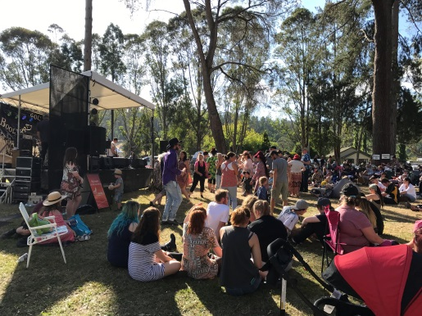
Case study: Boolarra Folk Festival
The Boolarra Folk Festival in March each year is an important annual community event within the Latrobe Valley region. The festival attracts up to ten thousand people many of whom travel from outside the district to attend.
Last year, the festival coordinators decided to extend the program in 2017 and scheduled events over Friday evening, Saturday and Sunday afternoon.
The Latrobe Valley Authority was able to support the expansion with a $5,000, Community Event grant resulting in more food, more music, more fun and a bigger crowd.

To access support, or for more information, contact the Latrobe Valley Authority.
Website: lva.vic.gov.au Address: 131 Princes Drive, Morwell VIC 3840 Phone: 1800 136 762

